**Introduction**

**Background**

**Scientific Question:** How resilient are the coral reefs in the North Pacific Ocean to climate change?

**Regional Setting and Time Frame**

The boundary of our research project is set in the North Pacific Ocean as it contains the most number of coral species, and has occurrences of mass bleaching events (NOAA, 2017) that we can research on. The North Pacific Ocean also contains National Marine Sanctuaries and Marine Protected Areas (Friends of Midway Atoll National Wildlife Refuge, 2017) which are effective in enhancing coral survivability in the face of climate change. The presence of these sites limits anthropogenic factors that causes coral bleaching, such as overfishing and tourism, thereby allowing us to produce more accurate results.

The time frame of our project is from 2000 to 2015 due to the availability of reliable datasets. Coral bleaching phenomena has also increased greatly since 2000, making it a suitable time to conduct research of bleaching resilience.

|  |  |  |  |
| --- | --- | --- | --- |
| **Datasets** | **Description** | **Format** | **Source** |
| 1.Sea Surface Temperature (SST)  2. Sea Surface Temperature Anomaly (SSTA)  3.Degree Heating Weeks (DHW)  4.Hotspots | Different parameters of climate change recorded at various stations located in the North Pacific Ocean | Text file (.txt) | NOAA coral reef Watch Virtual Stations |
| Coral species distribution | Different species of corals and their locations in the North Pacific Ocean | Comma separate values (.csv) | NOAA Deep Sea Coral database |
| Ocean Heat content (Joules) | Yearly global ocean heat content | Comma separate values (.csv) | NOAA, CSIRO, MRI/JMA |
| SST max, SST anomaly min, max, mean, hotspot max, DHW max | Annual Composites  of Twice-Weekly 50-km Satellite Coral Bleaching Monitoring Products | Hierarchical data format (.hdf) | NOAA Satellite and Information Service |
| Hawaii Ocean Time-Series (HOT) surface CO2 system data product | Mean seawater salinity normalized Dissolved Inorganic Carbon (total CO2 concentration),  Mean seawater pH | Textfile (.txt) | Hawaii Ocean Time-series (HOT) program |

**Role in project**

In this project, my role is to find the correlation between climate change and coral population. To do this, I loaded and plotted the graphs for coral population, ocean heat content, sea surface temperature (SST), SST anomaly, CO2 and pH levels in the North Pacific Ocean. After that, I correlated all the climate change indicators (including DHW and Hotspots data) with coral population. I also used MATLAB to make a function to obtain years whereby coral population decreased and assisted Skye and Ze Ming by making a function to read coral distribution data into MATLAB.

**Assumptions**

To answer our scientific question, our group assumes that the parameters indicative of climate change are sea surface temperatures and their anomalies, ocean heat content, CO2 and pH levels. These in turn causes increases in hotspots and degree heating weeks, resulting in coral bleaching and death.

Next, due to the limitations of our coral population dataset. Our group will use the number of yearly coral records as a proxy for yearly coral population. As such, a decrease in coral records represents a decrease in coral population.

**MATLAB Techniques**

The table below describes the challenges faced when working with the datasets, as well as the steps taken to resolve these challenges.

|  |  |
| --- | --- |
| **SST and SST anomaly dataset** | |
| Challenges | Resolution |
| 42 different text files corresponding to 42 stations in the north pacific must be read into MATLAB, and stored in a matrix.  Dataset contains monthly records. However, we require a yearly mean record. | 1. Create a vector containing the filenames of all the datasets.  2. Create another vector containing the years 2000 to 2015 in double format.  4. Create empty matrix to store a column of yearly station data.  3.Create an empty matrix to store all the columns of yearly data.  4. Create a ***for*** loop that loops through the vector of filenames, and use ***textread*** to read SST data in the station to MATLAB.  5. Create another ***for*** loop that loops through the vector of years, and use ***find*** to obtain indexes that correspond to months in the specified year in my loop  6. Use ***mean*** to calculate the mean of all the monthly data  7. Store the SST data in a column in the empty matrix. End the first loop  8. Store the previous column of data in the other empty matrix.  9. Finally, I will obtain a 16 x 42 matrix, each row corresponds to years and each column corresponds to each station.  10. Create the same loops to SST anomaly date |
| Obtaining yearly mean of north pacific SST and SST anomalies by monthly data in 42 stations in the North Pacific | 1. Create an empty matrix to store yearly mean SST in the North Pacific.  2. Create a for loop, the loop will run through each row in the earlier 16x42 matrix.  3. Use the ***mean*** function to calculate yearly mean of north pacific SST and SST anomalies |
| **Coral Distribution dataset** | |
| The function ***textread*** could not be used to load the .csv file | The function ***cd_sc*** was created to load the data instead.  In the function, ***importdata*** was used to load the data into MATLAB in a structure format. Struct2cell was then used to convert the data in to a cell format. |
| Some of the coral distribution data files are ‘corrupted’: datasets for the years 2001 to 2013 contains 3 additional empty columns. | Another function ***cd_sc2*** was created to load the ‘corrupted’ datasets.  2 different loops are used to load the ‘corrupted’ and uncorrupted datasets into MATLAB. |
| **Ocean heat content dataset** | |
| There are no significant problems in the dataset | Data can be loaded and plotted easily on MATLAB |
| **pH and dissolved inorganic carbon dataset** | |
| Dates are in string and in dd-mm-yyyy format (eg. ’01-Jan-01’)  Hence the function ***find*** cannot be used for *cell* formats | 1. Use ***cell2mat*** function to convert the dates in the *cell* format to *char* format in a single matrix  2. Next, use ***datenum*** function to convert the dates into days since 00 Jan 000.  3. **datevec** function is then used to create a numeric array (cell type double) containing the dates in years, months, days, hours, minutes and seconds.  4. The ***find*** function can now be used |
| Dataset contains monthly records. However, we require a yearly mean record. | 1. Create a vector containing the years 2000 to 2015 in double format.  2. Create an empty matrix to store a column of yearly station data.  3. Create a ***for*** loop that loops through the vector of years, and use ***find*** to obtain indexes that correspond to months in the specified year in my loop  4. Use ***mean*** to calculate the mean of all the monthly data  5. Store the CO2 data in a column in the empty matrix. End the loop |

**Limitations of my datasets**

The pH and dissolved inorganic carbon dataset is missing some monthly data. Hence when converting the monthly data to yearly data, the mean yearly data is not fully representative of all the months. For our overall analysis, of yearly datasets are used, this means that the datasets do not fully represent seasonal, monthly and daily fluctuations. As such, there may be cyclicities that are not accounted for in our analysis. Finally, climate change is a complex system of many factors integrated together. It is very difficult to quantify the combined effects of the different factors to simulate real life scenarios. Therefore, we are only able to measure these parameters individually.

**Preliminary results and discussion**

My results showed that the coral records show a negative correlation with ocean heat content, sea surface temperature (SST), SST anomaly, CO2, hotspots and degree heating weeks. There is a positive correlation with pH levels and global ocean heat content (Figure ). Except for global heat content, all other climate change indicators support the group’s hypothesis.

This observation supports our hypothesis that **climate change has a high likelihood of causing a reduction in the coral population.** This link between Climate Change and decrease in Coral Population have also been well researched on (Hoegh-Guldberg et al.,2017 and Hughes, 2003).

Our ocean heat content data appears to be an anomaly because it shows a positive correlation. This is because the ocean heat content data represents global mean values, it may not correctly represent the ocean heat content in the North Pacific.

Next, the plot of coral records over time showed drastic coral reductions in the years 2010 and 2014, which also coincides with the duration of two recorded global mass bleaching events. For further analysis, our group decided to analyse the resilience of individual coral species resilience based on the 2 global bleaching events.

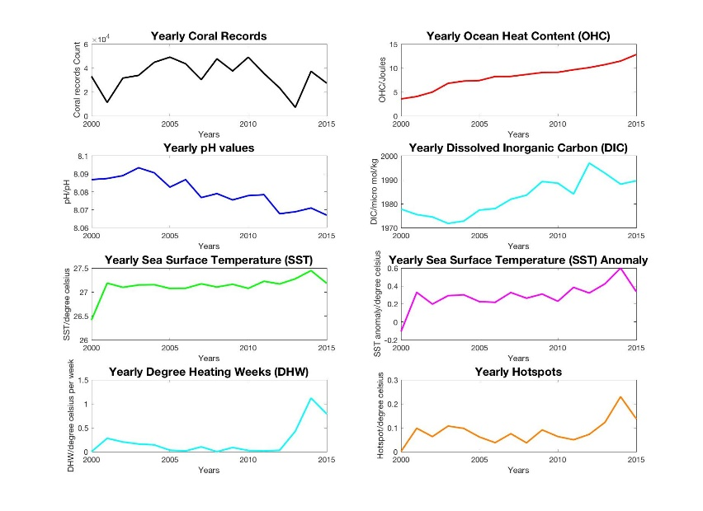

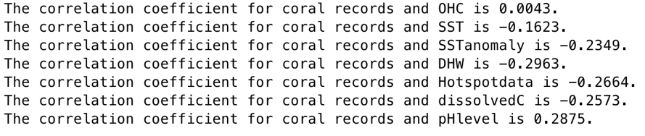

**Final discussion and conclusion**

**Final conclusion**

In conclusion, analysis from correlating climate change indicators to coral population showed a high likelihood that worsening climate change will lead to coral bleaching and coral deaths. From which, there are drastic reduction in coral population in years 2010 and 2014. Based on analysing these 2 events, we concluded that are is varying levels of resilience within different species of corals. Soft corals and demosponges are the least resilient to climate change, followed by black corals and sponges. Glass sponges and gorgonian sponges displayed a growing resilience to climate change as these corals can adapt to worsening conditions. Finally, the sea pens are the most resilient species as they increased in population in both bleaching events.